Helm Lab

:Q1

→ clone python-app github repo

→ Create Dockerfile to build image for this app :

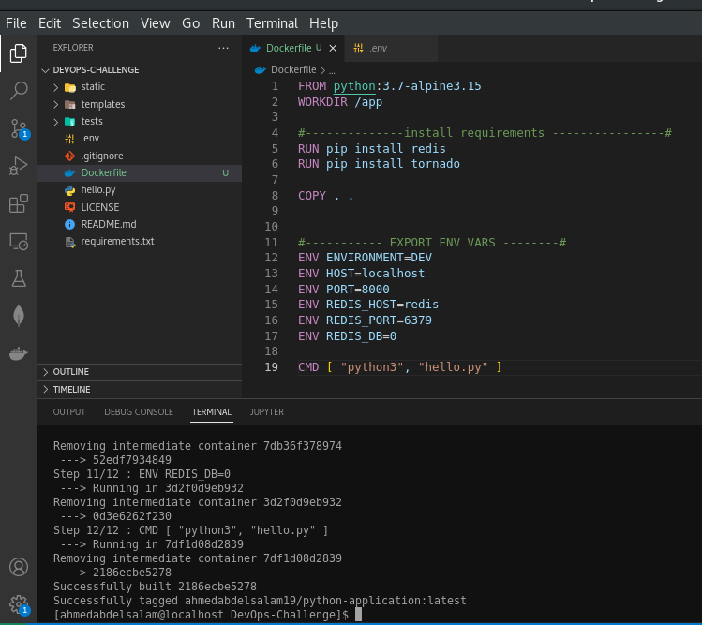

→ build image
→ tag image
→ push image to Dockerhub
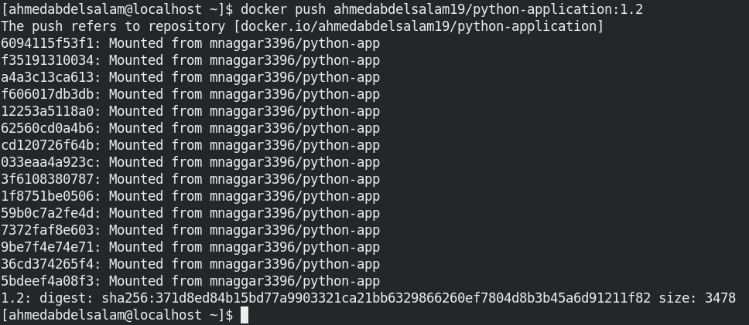
→ create chart <python-application>
→ create deployment and service for both [python app and redis]

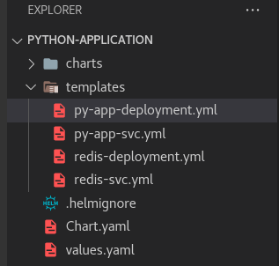

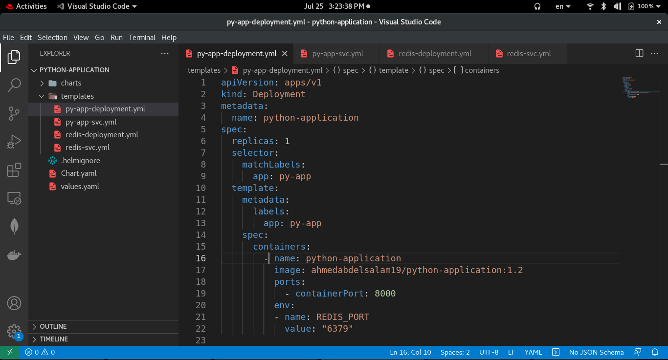
→ helm install for python-application

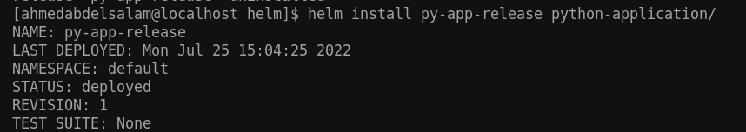
get ip for service:
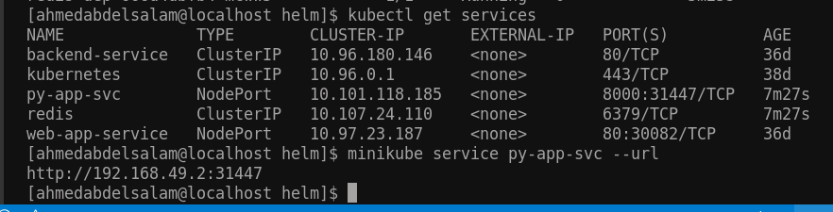

completed !

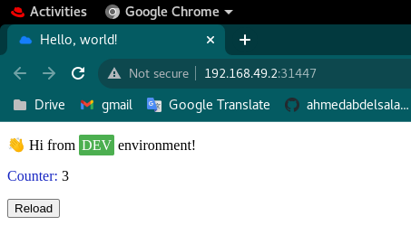

Q2:Deploy Jenkins Chart on the cluster and login to jenkins

→ get and update jenkins repo

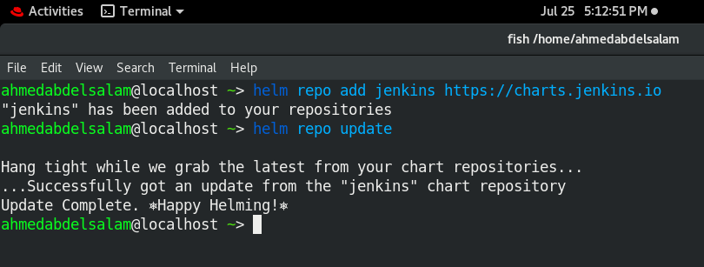

→ create and update jenkins release

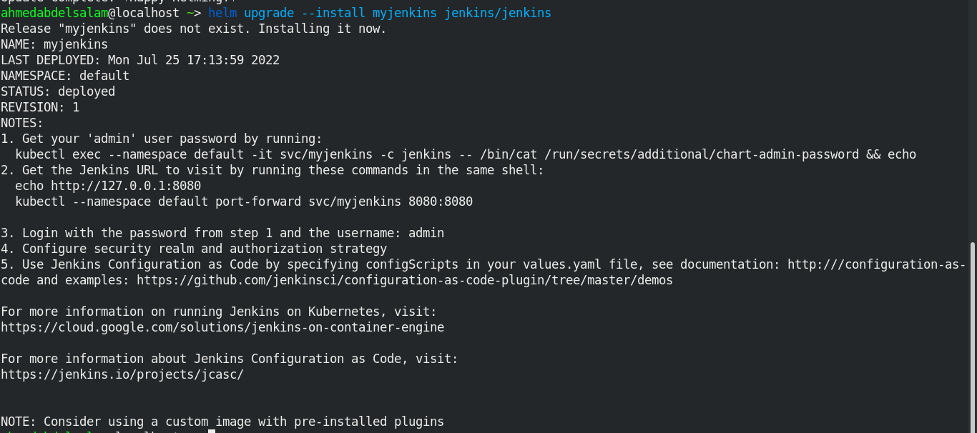

→ execute notes from above result
1- get admin user password
2- get myjenkins url

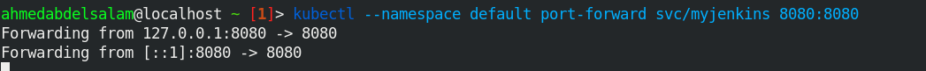
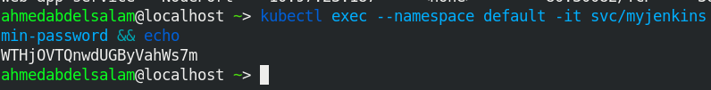

→ login to jenkins
